# 第七单元 Dubbo项目整合

# 【授课重点】

1. 创建Maven聚合dubbo项目

# 【考核要求】

1. 独立创建Maven聚合dubbo项目

# 【教学内容】

## 7.1 课程导入

企业Maven的dubbo聚合项目应用比较广泛，我们在实际中怎么完成项目的创建尼

## 7.2 创建Mavan聚合dubbo项目

### 7.2.1 创建聚合项目父工程

创建聚合项目父工程名称：lianxi*dubbo*parent

### create a maven Project

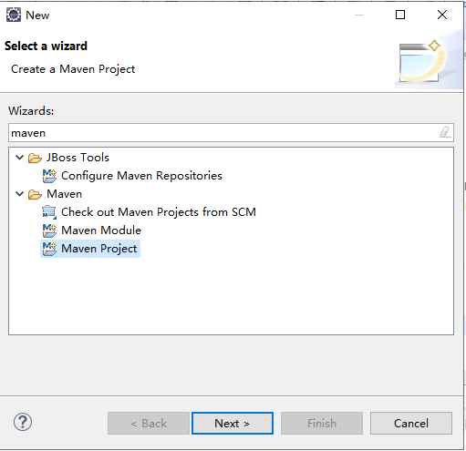

### Next>

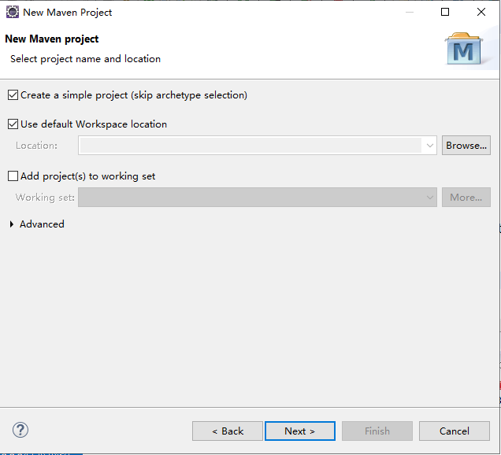

勾选上 Create a simple project

### Next>

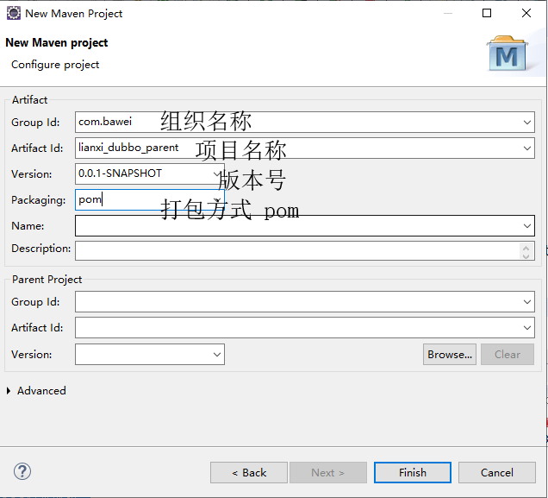

### Finish

### pom.xml文件加入依赖管理(认真读读)

<!-- 定义主要版本号 -->  
 <properties>  
 <spring.version>5.1.5.RELEASE</spring.version>  
 <mybatis.version>3.4.2</mybatis.version>  
 <log4j.version>1.2.17</log4j.version>  
 <druid.version>1.0.9</druid.version>  
 <mysql.version>5.1.6</mysql.version>  
 <mybatis.spring.version>1.3.0</mybatis.spring.version>  
 <jackson.version>2.9.1</jackson.version>  
 <validator.version>5.1.0.Final</validator.version>  
 <poi.version>3.9</poi.version>  
 <jstl.version>1.2</jstl.version>  
 <servlet-api.version>2.5</servlet-api.version>  
 <jsp-api.version>2.0</jsp-api.version>  
 <commons-lang3.version>3.3.2</commons-lang3.version>  
 <commons-io.version>1.3.1</commons-io.version>  
 <commons-net.version>3.3</commons-net.version>  
 <commons-fileupload.version>1.3.1</commons-fileupload.version>  
 <junit-version>4.12</junit-version>  
 <!-- aop使用 -->  
 <aspectj-version>1.8.0</aspectj-version>  
 <!-- 分页助手 -->  
 <jedis.version>2.9.0</jedis.version>  
 <pagehelper-version>5.1.2</pagehelper-version>  
 <dubbo.version>2.7.3</dubbo.version>  
 <jsp-api.version>2.2</jsp-api.version>  
 <json-simple.version>1.1.1</json-simple.version>  
 <gson.version>2.8.5</gson.version>  
 <kafka.version>0.8.2.1</kafka.version>  
 <ik.version>2012_u6</ik.version>  
 <lucene.version>7.2.1</lucene.version>  
 <spring-kafka.version>2.2.4.RELEASE</spring-kafka.version>  
 <spring-data-redis.version>2.1.5.RELEASE</spring-data-redis.version>  
 <spring-data-elasticsearch.version>3.1.5.RELEASE</spring-data-elasticsearch.version>  
 <validation-api.version>2.0.1.Final</validation-api.version>  
 <fastjson.version>1.2.7</fastjson.version>  
 </properties>  
  
  
  
 <dependencyManagement>  
  
 <dependencies>  
  
 <dependency>  
 <groupId>com.alibaba</groupId>  
 <artifactId>fastjson</artifactId>  
 <version>${fastjson.version}</version>  
 </dependency>  
  
 <!-- 引入dubbo的依赖配置 -->  
 <dependency>  
 <groupId>org.apache.dubbo</groupId>  
 <artifactId>dubbo</artifactId>  
 <version>${dubbo.version}</version>  
 <exclusions>  
 <exclusion>  
 <groupId>io.netty</groupId>  
 <artifactId>netty-all</artifactId>  
 </exclusion>  
 <exclusion>  
 <artifactId>org.springframework</artifactId>  
 <groupId>spring-context</groupId>  
 </exclusion>  
 </exclusions>  
 </dependency>  
 <dependency>  
 <groupId>org.apache.dubbo</groupId>  
 <artifactId>dubbo-dependencies-zookeeper</artifactId>  
 <version>${dubbo.version}</version>  
 <type>pom</type>  
 </dependency>  
  
 <!-- validation-api -->  
 <dependency>  
 <groupId>javax.validation</groupId>  
 <artifactId>validation-api</artifactId>  
 <version>${validation-api.version}</version>  
 </dependency>  
 <!-- 单独引入lucene项目的分词器 -->  
 <dependency>  
 <groupId>org.apache.lucene</groupId>  
 <artifactId>lucene-core</artifactId>  
 <version>${lucene.version}</version>  
 </dependency>  
 <!-- 加入ik分词器 -->  
 <dependency>  
 <groupId>com.janeluo</groupId>  
 <artifactId>ikanalyzer</artifactId>  
 <version>${ik.version}</version>  
 <!-- 排除自带的lucene操作 -->  
 <exclusions>  
 <exclusion>  
 <groupId>org.apache.lucene</groupId>  
 <artifactId>lucene-queries</artifactId>  
 </exclusion>  
 <exclusion>  
 <groupId>org.apache.lucene</groupId>  
 <artifactId>lucene-queryparser</artifactId>  
 </exclusion>  
 </exclusions>  
 </dependency>  
  
 <!-- 引入spring-kafka依赖 -->  
 <dependency>  
 <groupId>org.springframework.kafka</groupId>  
 <artifactId>spring-kafka</artifactId>  
 <version>${spring-kafka.version}</version>  
 </dependency>  
 <!-- kafka的依赖 -->  
 <dependency>  
 <groupId>org.apache.kafka</groupId>  
 <artifactId>kafka_2.10</artifactId>  
 <version>${kafka.version}</version>  
 <exclusions>  
 <exclusion>  
 <artifactId>jmxri</artifactId>  
 <groupId>com.sun.jmx</groupId>  
 </exclusion>  
 <exclusion>  
 <artifactId>jms</artifactId>  
 <groupId>javax.jms</groupId>  
 </exclusion>  
 <exclusion>  
 <artifactId>jmxtools</artifactId>  
 <groupId>com.sun.jdmk</groupId>  
 </exclusion>  
 </exclusions>  
 </dependency>  
  
 <!-- 引入 redis.clients/jedis 依赖 -->  
 <dependency>  
 <groupId>redis.clients</groupId>  
 <artifactId>jedis</artifactId>  
 <version>${jedis.version}</version>  
 </dependency>  
  
 <!-- 引入 spring-data-redis 依赖 -->  
 <dependency>  
 <groupId>org.springframework.data</groupId>  
 <artifactId>spring-data-redis</artifactId>  
 <version>${spring-data-redis.version}</version>  
 </dependency>  
  
  
 <!-- spring-core 依赖 -->  
 <dependency>  
 <groupId>org.springframework</groupId>  
 <artifactId>spring-core</artifactId>  
 <!-- 引用版本 -->  
 <version>${spring.version}</version>  
 </dependency>  
  
 <!-- spring-context 依赖 -->  
 <dependency>  
 <groupId>org.springframework</groupId>  
 <artifactId>spring-context</artifactId>  
 <version>${spring.version}</version>  
 </dependency>  
  
 <!-- spring-beans依赖 -->  
 <dependency>  
 <groupId>org.springframework</groupId>  
 <artifactId>spring-beans</artifactId>  
 <version>${spring.version}</version>  
 </dependency>  
 <!-- spring-web依赖 -->  
 <dependency>  
 <groupId>org.springframework</groupId>  
 <artifactId>spring-web</artifactId>  
 <version>${spring.version}</version>  
 </dependency>  
 <!-- spring-webmvc依赖 -->  
 <dependency>  
 <groupId>org.springframework</groupId>  
 <artifactId>spring-webmvc</artifactId>  
 <version>${spring.version}</version>  
 </dependency>  
 <!-- spring-jdbc依赖 -->  
 <dependency>  
 <groupId>org.springframework</groupId>  
 <artifactId>spring-jdbc</artifactId>  
 <version>${spring.version}</version>  
 </dependency>  
 <!-- spring-tx 事务依赖 -->  
 <dependency>  
 <groupId>org.springframework</groupId>  
 <artifactId>spring-tx</artifactId>  
 <version>${spring.version}</version>  
 </dependency>  
 <!-- spring-context-support上下文依赖 -->  
 <dependency>  
 <groupId>org.springframework</groupId>  
 <artifactId>spring-context-support</artifactId>  
 <version>${spring.version}</version>  
 </dependency>  
 <!-- 引入spring-test依赖 -->  
 <dependency>  
 <groupId>org.springframework</groupId>  
 <artifactId>spring-test</artifactId>  
 <version>${spring.version}</version>  
 </dependency>  
  
 <!-- mybatis核心包 -->  
 <dependency>  
 <groupId>org.mybatis</groupId>  
 <artifactId>mybatis</artifactId>  
 <version>${mybatis.version}</version>  
 </dependency>  
 <!-- mybatis-spring 整合jar -->  
 <dependency>  
 <groupId>org.mybatis</groupId>  
 <artifactId>mybatis-spring</artifactId>  
 <version>${mybatis.spring.version}</version>  
 </dependency>  
 <!-- druid数据源 -->  
 <dependency>  
 <groupId>com.alibaba</groupId>  
 <artifactId>druid</artifactId>  
 <version>${druid.version}</version>  
 </dependency>  
 <!-- Mysql数据库驱动包 -->  
 <dependency>  
 <groupId>mysql</groupId>  
 <artifactId>mysql-connector-java</artifactId>  
 <version>${mysql.version}</version>  
 </dependency>  
 <!-- 日志文件管理包 -->  
 <!-- log start -->  
 <dependency>  
 <groupId>log4j</groupId>  
 <artifactId>log4j</artifactId>  
 <version>${log4j.version}</version>  
 </dependency>  
 <!-- 单元测试 -->  
 <dependency>  
 <groupId>junit</groupId>  
 <artifactId>junit</artifactId>  
 <version>${junit-version}</version>  
 <scope>test</scope>  
 </dependency>  
 <!-- 上传组件包 -->  
 <dependency>  
 <groupId>commons-fileupload</groupId>  
 <artifactId>commons-fileupload</artifactId>  
 <version>${commons-fileupload.version}</version>  
 </dependency>  
 <!-- common-io依赖 -->  
 <dependency>  
 <groupId>commons-io</groupId>  
 <artifactId>commons-io</artifactId>  
 <version>${commons-io.version}</version>  
 </dependency>  
 <!-- poi execl操作依赖 -->  
 <dependency>  
 <groupId>org.apache.poi</groupId>  
 <artifactId>poi</artifactId>  
 <version>${poi.version}</version>  
 </dependency>  
 <!-- 引入jstl依赖 -->  
 <dependency>  
 <groupId>jstl</groupId>  
 <artifactId>jstl</artifactId>  
 <version>${jstl.version}</version>  
 </dependency>  
 <!-- 引入jsp-api依赖 -->  
 <dependency>  
 <groupId>javax.servlet.jsp</groupId>  
 <artifactId>jsp-api</artifactId>  
 <version>${jsp-api.version}</version>  
 <scope>provided</scope>  
 </dependency>  
 <dependency>  
 <groupId>javax.servlet</groupId>  
 <artifactId>servlet-api</artifactId>  
 <version>${servlet-api.version}</version>  
 <scope>provided</scope>  
 </dependency>  
  
 <!-- 引入jackson的依赖 -->  
 <dependency>  
 <groupId>com.fasterxml.jackson.core</groupId>  
 <artifactId>jackson-databind</artifactId>  
 <version>${jackson.version}</version>  
 </dependency>  
  
 <!-- 依赖的公共包 -->  
 <dependency>  
 <groupId>org.apache.commons</groupId>  
 <artifactId>commons-lang3</artifactId>  
 <version>${commons-lang3.version}</version>  
 </dependency>  
  
 <!-- 引入org.aspectj依赖 -->  
 <dependency>  
 <groupId>org.aspectj</groupId>  
 <artifactId>aspectjweaver</artifactId>  
 <version>${aspectj-version}</version>  
 </dependency>  
 <dependency>  
 <groupId>org.aspectj</groupId>  
 <artifactId>aspectjrt</artifactId>  
 <version>${aspectj-version}</version>  
 </dependency>  
 <!-- 引入验证依赖 -->  
 <dependency>  
 <groupId>org.hibernate</groupId>  
 <artifactId>hibernate-validator</artifactId>  
 <version>${validator.version}</version>  
 </dependency>  
  
 <!-- 引入mybaits pagehelper分页助手依赖 -->  
 <dependency>  
 <groupId>com.github.pagehelper</groupId>  
 <artifactId>pagehelper</artifactId>  
 <version>${pagehelper-version}</version>  
 </dependency>  
  
  
  
 <!-- 富文本编辑器使用该文件上传 -->  
 <dependency>  
 <groupId>com.googlecode.json-simple</groupId>  
 <artifactId>json-simple</artifactId>  
 <version>${json-simple.version}</version>  
 </dependency>  
  
 <!-- google Gson -->  
 <dependency>  
 <groupId>com.google.code.gson</groupId>  
 <artifactId>gson</artifactId>  
 <version>${gson.version}</version>  
 </dependency>  
  
 <!-- spring-data-elasticsearch 提高到3.1.5 -->  
 <dependency>  
 <groupId>org.springframework.data</groupId>  
 <artifactId>spring-data-elasticsearch</artifactId>  
 <version>${spring-data-elasticsearch.version}</version>  
 </dependency>  
 </dependencies>  
 </dependencyManagement>  
  
  
  
 <build>  
 <plugins>  
 <!-- 引入jetty -->  
 <plugin>  
 <groupId>org.eclipse.jetty</groupId>  
 <artifactId>jetty-maven-plugin</artifactId>  
 <version>9.4.20.v20190813</version>  
 <configuration>  
 <httpConnector>  
 <!-- 端口号 -->  
 <port>80</port>  
 <!-- 项目访问路径 -->  
 <host>localhost</host>  
 </httpConnector>  
 <contextHandlers>  
 <jettyWebAppContext>  
 <!-- 虚拟路径 -->  
 <contextPath>/pic</contextPath>  
 <!-- 物理路径 -->  
 <resourceBase>d:/pic/</resourceBase>  
 </jettyWebAppContext>  
 </contextHandlers>  
 <scanIntervalSeconds>1</scanIntervalSeconds>  
 </configuration>  
 </plugin>  
  
 <!-- 打包去掉测试类 -->  
 <plugin>  
 <groupId>org.apache.maven.plugins</groupId>  
 <artifactId>maven-surefire-plugin</artifactId>  
 <version>2.18.1</version>  
 <configuration>  
 <skipTests>true</skipTests>  
 </configuration>  
 </plugin>  
  
 <!-- 编译的环境 jdk版本1.8 -->  
 <plugin>  
 <groupId>org.apache.maven.plugins</groupId>  
 <artifactId>maven-compiler-plugin</artifactId>  
 <version>3.5.1</version>  
 <configuration>  
 <source>1.8</source>  
 <target>1.8</target>  
 <encoding>UTF-8</encoding>  
 </configuration>  
 </plugin>  
  
 </plugins>  
 </build>

### 7.2.2 创建服务接口模块

创建服务接口模块名称：lianxi*dubbo*interface

### create a Maven module

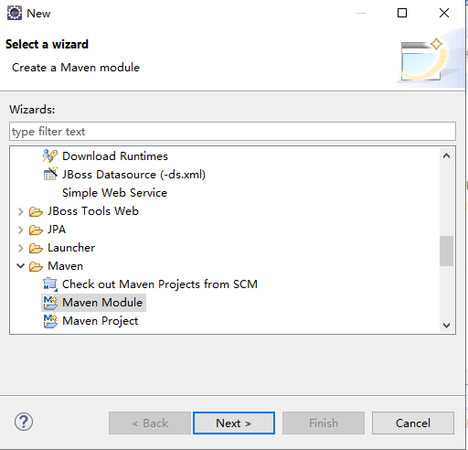

### Next>

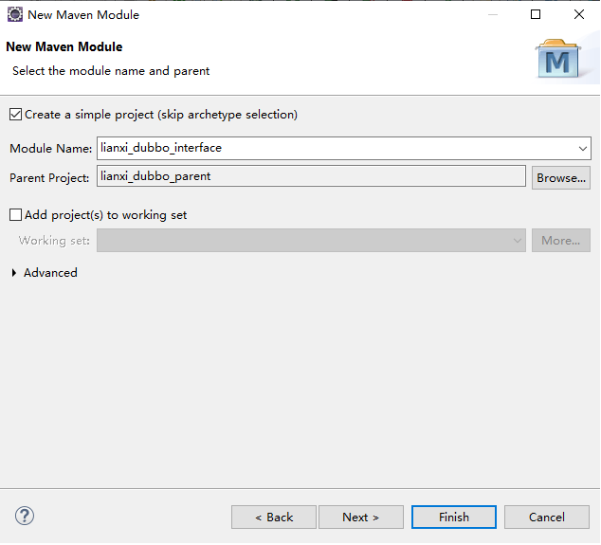

### Next>

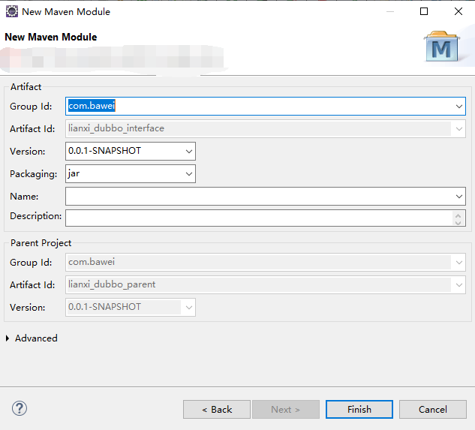

打包方式是jar

Finish完成

### pom.xml文件加入依赖管理 (考虑到es整合，结合专高二课程)

<dependencies>  
 <!-- spring-data-elasticsearch 提高到3.1.5 -->  
 <dependency>  
 <groupId>org.springframework.data</groupId>  
 <artifactId>spring-data-elasticsearch</artifactId>  
 </dependency>  
 </dependencies>

### 创建服务接口

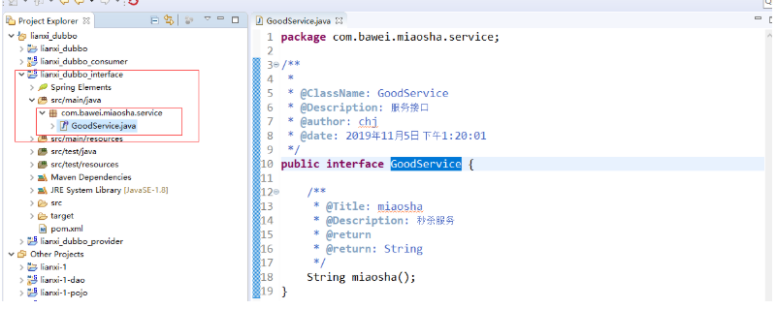

### 7.2.3 创建服务的提供者

创建服务提供者名称lianxi*dubbo*provider

备注：打包方式是war

步骤：参考1.2

### pom.xml文件加入依赖(记得修改jetty端口号：81(任何不冲突端口号))

<dependencies>  
  
 <!-- 引入dubbo的依赖配置 -->  
 <dependency>  
 <groupId>org.apache.dubbo</groupId>  
 <artifactId>dubbo</artifactId>  
 </dependency>  
 <dependency>  
 <groupId>org.apache.dubbo</groupId>  
 <artifactId>dubbo-dependencies-zookeeper</artifactId>  
 <type>pom</type>  
 </dependency>  
   
 <!-- spring -web依赖 -->  
 <dependency>  
 <groupId>org.springframework</groupId>  
 <artifactId>spring-web</artifactId>  
 </dependency>  
  
 <dependency>  
 <groupId>org.springframework</groupId>  
 <artifactId>spring-webmvc</artifactId>  
 </dependency>  
   
 <dependency>  
 <groupId>com.bawei</groupId>  
 <artifactId>lianxi_dubbo_interface</artifactId>  
 <version>0.0.1-SNAPSHOT</version>  
 </dependency>  
 </dependencies>  
   
   
 <build>  
 <plugins>  
 <!-- 引入jetty -->  
 <plugin>  
 <groupId>org.eclipse.jetty</groupId>  
 <artifactId>jetty-maven-plugin</artifactId>  
 <version>9.4.20.v20190813</version>  
 <configuration>  
 <httpConnector>  
 <!-- 端口号 -->  
 <port>81</port>  
 <!-- 项目访问路径 -->  
 <host>localhost</host>  
 </httpConnector>  
 <contextHandlers>  
 <jettyWebAppContext>  
 <!-- 虚拟路径 -->  
 <contextPath>/pic</contextPath>  
 <!-- 物理路径 -->  
 <resourceBase>d:/pic/</resourceBase>  
 </jettyWebAppContext>  
 </contextHandlers>  
 <scanIntervalSeconds>1</scanIntervalSeconds>  
 </configuration>  
 </plugin>  
  
 <!-- 打包去掉测试类 -->  
 <plugin>  
 <groupId>org.apache.maven.plugins</groupId>  
 <artifactId>maven-surefire-plugin</artifactId>  
 <version>2.18.1</version>  
 <configuration>  
 <skipTests>true</skipTests>  
 </configuration>  
 </plugin>  
  
 <!-- 编译的环境 jdk版本1.8 -->  
 <plugin>  
 <groupId>org.apache.maven.plugins</groupId>  
 <artifactId>maven-compiler-plugin</artifactId>  
 <version>3.5.1</version>  
 <configuration>  
 <source>1.8</source>  
 <target>1.8</target>  
 <encoding>UTF-8</encoding>  
 </configuration>  
 </plugin>  
  
 </plugins>  
 </build>

### 创建服务的实现

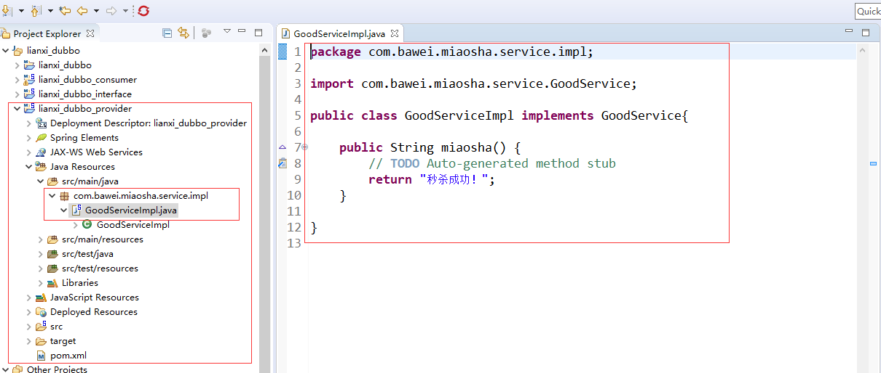

### 服务注册到zookeeper的配置文件 provider.xml

fig:

具体内容：（**读读里边的配置**)

<?xml version="1.0" encoding="UTF-8"?>  
<beans xmlns="http://www.springframework.org/schema/beans"  
 xmlns:xsi="http://www.w3.org/2001/XMLSchema-instance"  
 xmlns:dubbo="http://dubbo.apache.org/schema/dubbo"  
 xsi:schemaLocation="http://www.springframework.org/schema/beans   
 http://www.springframework.org/schema/beans/spring-beans-4.3.xsd   
 http://dubbo.apache.org/schema/dubbo   
 http://dubbo.apache.org/schema/dubbo/dubbo.xsd">  
  
 <!-- 提供方应用信息，用于计算依赖关系 -->  
 <dubbo:application name="hello-world-app" />  
  
 <!-- 使用zookeeper注册中心暴露服务地址 -->  
 <dubbo:registry  
 address="zookeeper://192.168.73.129:2181" />  
  
 <!-- 用dubbo协议在20880端口暴露服务 -->  
 <dubbo:protocol name="dubbo" port="20880" />  
  
 <!-- 声明需要暴露的服务接口 -->  
 <dubbo:service  
 interface="com.bawei.miaosha.service.GoodService" ref="goodService" />  
  
 <!-- 和本地bean一样实现服务 -->  
 <bean id="goodService"  
 class="com.bawei.miaosha.service.impl.GoodServiceImpl" />  
</beans>

以上标签：dubbo:application,dubbo:registry,dubbo:protocol,dubbo:service 记得背一下。

### 在web.xml文件中加入启动服务的配置，通过spring容器操作

<!-- 启动spring -->  
 <context-param>  
 <param-name>contextConfigLocation</param-name>  
 <param-value>classpath:provider.xml</param-value>  
 </context-param>  
 <listener>  
 <listener-class>org.springframework.web.context.ContextLoaderListener</listener-class>  
 </listener>

服务的提供者只是注册服务到zookeeper的注册中心，当通过jetty:run启动服务的时候(前提先启动zookeeper服务)，就可以在zookeeper的客户端的根节点中查看。

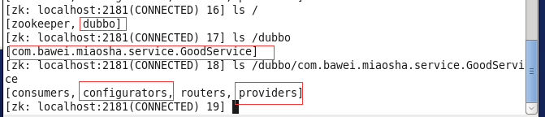

图上红色的部分就是可以查看到的节点。

### 7.2.4 创建服务的消费者

消费者名称：lianxi*dubbo*consumer

备注：打包方式是war

步骤：参考1.2

### pom.xml文件加入依赖(记得修改jetty端口号：82（任何不冲突端口号）)

<dependencies>  
  
 <!-- 引入dubbo的依赖配置 -->  
 <dependency>  
 <groupId>org.apache.dubbo</groupId>  
 <artifactId>dubbo</artifactId>  
 </dependency>  
 <dependency>  
 <groupId>org.apache.dubbo</groupId>  
 <artifactId>dubbo-dependencies-zookeeper</artifactId>  
 <type>pom</type>  
 </dependency>  
  
  
 <!-- spring -web依赖 -->  
 <dependency>  
 <groupId>org.springframework</groupId>  
 <artifactId>spring-web</artifactId>  
 </dependency>  
  
 <dependency>  
 <groupId>org.springframework</groupId>  
 <artifactId>spring-webmvc</artifactId>  
 </dependency>  
  
  
  
 <!-- 验证依赖 -->  
 <dependency>  
 <groupId>org.hibernate</groupId>  
 <artifactId>hibernate-validator</artifactId>  
 </dependency>  
  
 <!-- validation-api -->  
 <dependency>  
 <groupId>javax.validation</groupId>  
 <artifactId>validation-api</artifactId>  
 </dependency>  
  
  
  
 <!-- 引入jstl依赖 -->  
 <dependency>  
 <groupId>jstl</groupId>  
 <artifactId>jstl</artifactId>  
 </dependency>  
 <!-- 引入jsp-api依赖 -->  
 <dependency>  
 <groupId>javax.servlet.jsp</groupId>  
 <artifactId>jsp-api</artifactId>  
 <scope>provided</scope>  
 </dependency>  
 <dependency>  
 <groupId>javax.servlet</groupId>  
 <artifactId>servlet-api</artifactId>  
 <scope>provided</scope>  
 </dependency>  
 <!-- 上传组件包 -->  
 <dependency>  
 <groupId>commons-fileupload</groupId>  
 <artifactId>commons-fileupload</artifactId>  
 </dependency>  
 <!-- common-io依赖 -->  
 <dependency>  
 <groupId>commons-io</groupId>  
 <artifactId>commons-io</artifactId>  
 </dependency>  
  
  
  
 <dependency>  
 <groupId>com.bawei</groupId>  
 <artifactId>lianxi_dubbo_interface</artifactId>  
 <version>0.0.1-SNAPSHOT</version>  
 </dependency>  
 </dependencies>  
  
 <build>  
 <plugins>  
 <!-- 引入jetty -->  
 <plugin>  
 <groupId>org.eclipse.jetty</groupId>  
 <artifactId>jetty-maven-plugin</artifactId>  
 <version>9.4.20.v20190813</version>  
 <configuration>  
 <httpConnector>  
 <!-- 端口号 -->  
 <port>82</port>  
 <!-- 项目访问路径 -->  
 <host>localhost</host>  
 </httpConnector>  
 <contextHandlers>  
 <jettyWebAppContext>  
 <!-- 虚拟路径 -->  
 <contextPath>/pic</contextPath>  
 <!-- 物理路径 -->  
 <resourceBase>d:/pic/</resourceBase>  
 </jettyWebAppContext>  
 </contextHandlers>  
 <scanIntervalSeconds>1</scanIntervalSeconds>  
 </configuration>  
 </plugin>  
  
 <!-- 打包去掉测试类 -->  
 <plugin>  
 <groupId>org.apache.maven.plugins</groupId>  
 <artifactId>maven-surefire-plugin</artifactId>  
 <version>2.18.1</version>  
 <configuration>  
 <skipTests>true</skipTests>  
 </configuration>  
 </plugin>  
  
 <!-- 编译的环境 jdk版本1.8 -->  
 <plugin>  
 <groupId>org.apache.maven.plugins</groupId>  
 <artifactId>maven-compiler-plugin</artifactId>  
 <version>3.5.1</version>  
 <configuration>  
 <source>1.8</source>  
 <target>1.8</target>  
 <encoding>UTF-8</encoding>  
 </configuration>  
 </plugin>  
  
 </plugins>  
 </build>

### 从zookeeper订阅服务，配置文件consumer.xml

<?xml version="1.0" encoding="UTF-8"?>  
<beans xmlns="http://www.springframework.org/schema/beans"  
 xmlns:xsi="http://www.w3.org/2001/XMLSchema-instance"  
 xmlns:dubbo="http://dubbo.apache.org/schema/dubbo"  
 xsi:schemaLocation="http://www.springframework.org/schema/beans   
 http://www.springframework.org/schema/beans/spring-beans.xsd   
 http://dubbo.apache.org/schema/dubbo   
 http://dubbo.apache.org/schema/dubbo/dubbo.xsd">  
   
 <!-- 消费方应用名，用于计算依赖关系，不是匹配条件，不要与提供方一样 -->  
 <dubbo:application name="consumer-of-helloworld-app" />  
   
 <!-- 使用zookeeper注册中心暴露发现服务地址 -->  
 <dubbo:registry address="zookeeper://192.168.73.129:2181" />  
   
 <!-- 生成远程服务代理，可以和本地bean一样使用demoService -->  
 <dubbo:reference id="goodService" interface="com.bawei.miaosha.service.GoodService" />  
</beans>

以上标签：dubbo:application,dubbo:register,dubbo:reference记得背一下。

### 创建一个App测试类

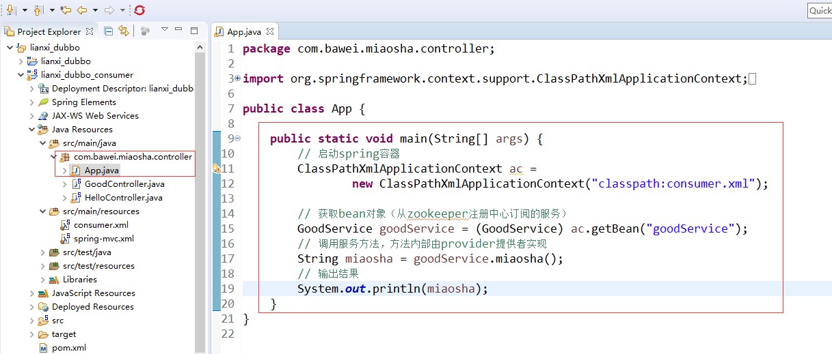

具体代码：

package com.bawei.miaosha.controller;  
  
import org.springframework.context.support.ClassPathXmlApplicationContext;  
  
import com.bawei.miaosha.service.GoodService;  
  
public class App {  
  
 public static void main(String[] args) {  
 // 启动spring容器  
 ClassPathXmlApplicationContext ac =   
 new ClassPathXmlApplicationContext("classpath:consumer.xml");  
  
 // 获取bean对象（从zookeeper注册中心订阅的服务）  
 GoodService goodService = (GoodService) ac.getBean("goodService");  
 // 调用服务方法，方法内部由provider提供者实现  
 String miaosha = goodService.miaosha();  
 // 输出结果  
 System.out.println(miaosha);  
 }  
}

运行此Java程序，能够看到 输出秒杀成功，证明dubbo环境测试通过

### 如果想通过web程序访问，创建controller类

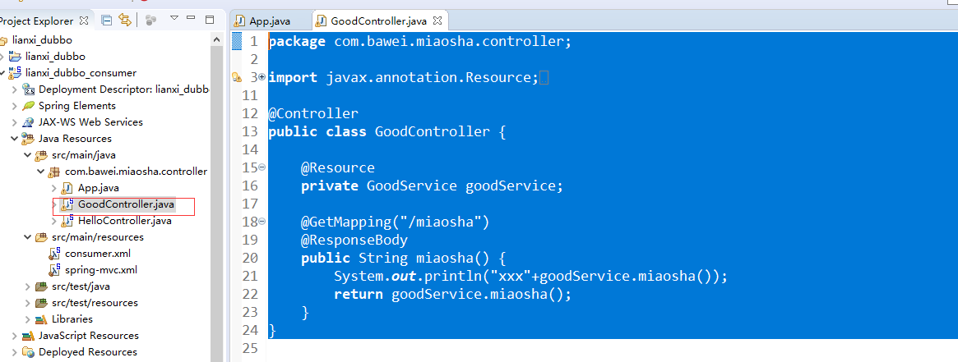

具体代码：

package com.bawei.miaosha.controller;  
  
import javax.annotation.Resource;  
  
import org.springframework.stereotype.Controller;  
import org.springframework.web.bind.annotation.GetMapping;  
import org.springframework.web.bind.annotation.RequestMapping;  
import org.springframework.web.bind.annotation.ResponseBody;  
  
import com.bawei.miaosha.service.GoodService;  
  
@Controller  
public class GoodController {  
   
 @Resource  
 private GoodService goodService;  
   
 @GetMapping("/miaosha")  
 @ResponseBody  
 public String miaosha() {  
 System.out.println("xxx"+goodService.miaosha());  
 return goodService.miaosha();  
 }  
}

### 在web.xml文件加入启动spring容器，和springwebmvc的配置

<!-- 启动spring -->  
 <context-param>  
 <param-name>contextConfigLocation</param-name>  
 <param-value>classpath:consumer.xml</param-value>  
 </context-param>  
 <listener>  
 <listener-class>org.springframework.web.context.ContextLoaderListener</listener-class>  
 </listener>  
   
   
 <!-- post请求乱码解决 -->  
 <filter>  
 <filter-name>CharacterEncodingFilter</filter-name>  
 <filter-class>org.springframework.web.filter.CharacterEncodingFilter</filter-class>  
 <init-param>  
 <param-name>encoding</param-name>  
 <param-value>utf-8</param-value>  
 </init-param>  
 </filter>  
 <filter-mapping>  
 <filter-name>CharacterEncodingFilter</filter-name>  
 <url-pattern>/*</url-pattern>  
 </filter-mapping>  
   
 <!-- 启动springMVC -->  
 <servlet>  
 <servlet-name>springDispatcherServlet</servlet-name>  
 <servlet-class>org.springframework.web.servlet.DispatcherServlet</servlet-class>  
 <init-param>  
 <param-name>contextConfigLocation</param-name>  
 <param-value>classpath:spring-mvc.xml</param-value>  
 </init-param>  
 <load-on-startup>1</load-on-startup>  
 </servlet>  
  
 <servlet-mapping>  
 <servlet-name>springDispatcherServlet</servlet-name>  
 <!-- 拦截所有的请求 -->  
 <url-pattern>/</url-pattern>  
 </servlet-mapping>

### spring-mvc.xml文件(记得修改扫描器的包名称)

<?xml version="1.0" encoding="UTF-8"?>  
<beans xmlns="http://www.springframework.org/schema/beans"  
 xmlns:xsi="http://www.w3.org/2001/XMLSchema-instance"  
 xmlns:context="http://www.springframework.org/schema/context"  
 xmlns:mvc="http://www.springframework.org/schema/mvc"  
 xsi:schemaLocation="http://www.springframework.org/schema/beans http://www.springframework.org/schema/beans/spring-beans.xsd  
 http://www.springframework.org/schema/context http://www.springframework.org/schema/context/spring-context-4.3.xsd  
 http://www.springframework.org/schema/mvc http://www.springframework.org/schema/mvc/spring-mvc-4.3.xsd">  
  
   
   
 <!-- 扫描器 -->  
 <context:component-scan  
 base-package="com.bawei.miaosha.controller"></context:component-scan>  
 <!-- 视图解析图 -->  
 <bean  
 class="org.springframework.web.servlet.view.InternalResourceViewResolver">  
 <!-- 配置前缀 -->  
 <property name="prefix" value="/WEB-INF/view/"></property>  
 <!-- 配置后缀 -->  
 <property name="suffix" value=".jsp"></property>  
 </bean>  
 <!-- 不拦截静态资源 -->  
 <mvc:default-servlet-handler />  
 <!-- mvc注解驱动 -->  
 <mvc:annotation-driven validator="validator"></mvc:annotation-driven>  
 <!-- 文件上传的处理类 -->  
 <bean id="multipartResolver"  
 class="org.springframework.web.multipart.commons.CommonsMultipartResolver"></bean>  
  
 <!-- hibernate 表单校验 -->  
 <bean id="validator"  
 class="org.springframework.validation.beanvalidation.LocalValidatorFactoryBean">  
 <property name="providerClass"  
 value="org.hibernate.validator.HibernateValidator"></property>  
 </bean>  
</beans>

### 通过浏览器访问:http://localhost:82/miaosha 测试能够看到输出结果，dubbo的web环境测试通过.

## 7.3 课程总结：

### 7.3.1 标签：背会的标签

|  |  |  |
| --- | --- | --- |
| 标签 | 用途 | 解释 |
| <dubbo:service/> | 服务配置 | 用于暴露一个服务，定义服务的元信息，一个服务可以用多个协议暴露，一个服务也可以注册到多个注册中心 |
| <dubbo:reference/> [[2]](http://dubbo.apache.org/zh-cn/docs/user/configuration/xml.html#fn2) | 引用配置 | 用于创建一个远程服务代理，一个引用可以指向多个注册中心 |
| <dubbo:protocol/> | 协议配置 | 用于配置提供服务的协议信息，协议由提供方指定，消费方被动接受 |
| <dubbo:application/> | 应用配置 | 用于配置当前应用信息，不管该应用是提供者还是消费者 |
| <dubbo:module/> | 模块配置 | 用于配置当前模块信息，可选 |
| <dubbo:registry/> | 注册中心配置 | 用于配置连接注册中心相关信息 |
| <dubbo:monitor/> | 监控中心配置 | 用于配置连接监控中心相关信息，可选 |
| <dubbo:provider/> | 提供方配置 | 当 ProtocolConfig 和 ServiceConfig 某属性没有配置时，采用此缺省值，可选 |
| <dubbo:consumer/> | 消费方配置 | 当 ReferenceConfig 某属性没有配置时，采用此缺省值，可选 |
| <dubbo:method/> | 方法配置 | 用于 ServiceConfig 和 ReferenceConfig 指定方法级的配置信息 |
| <dubbo:argument/> | 参数配置 | 用于指定方法参数配置 |

### 7.3.2 注册中心

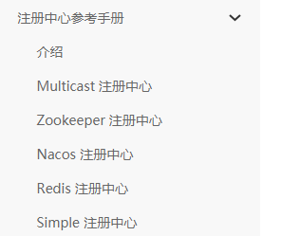

### 7.3.3 参考手册

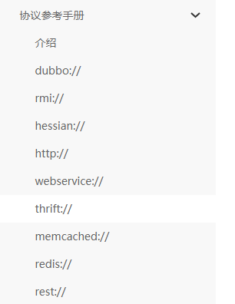

## 7.4 课程作业

在此项目的基础上，完成商品表的curd操作，商品表信息有：商品名称，价格，上架时间，商品图片,商品卖点.